**Site Purpose**:

The purpose of my Scoots site is to provide an exceptional experience for customers to easily, quickly, and efficiently make a rental reservation. My site is meant to provide the information in a simple to understand format and provide customers with all they need to make a confident rental decision for their time on Cozumel.

**Target Audience**:



**Persona 1: Jessica**

Jessica has traveled to several parts of Mexico and enjoys Cozumel as one of her favorite places to vacation. She is 30 years old, single, and loves travelling with friends. She enjoys getting out during her vacations to see the local areas and tries to get away from the tourist areas as much as possible.

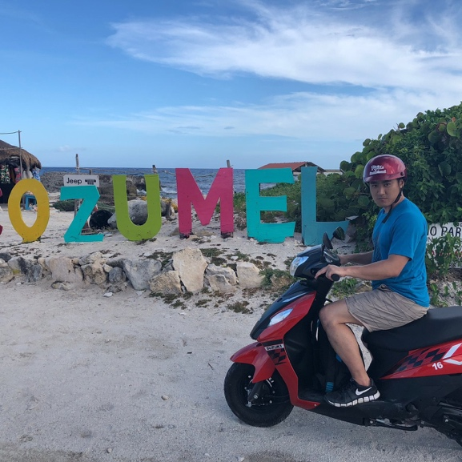

**Persona 2: Tim**

Tim travels to Cozumel for business occasionally and enjoys being able to experience the culture and atmosphere of the island when he is there. He is 35 years old and he enjoys getting to explore the different parts of Cozumel. He finds it is easiest and most affordable to travel by scooter. He especially loves finding great restaurants or food vendors to try good food and he finds that travelling by scooter allows him to scope out the best spots to try.



**Persona 3: Mike & Kelly**

Mike and Kelly just got married and chose to go to Cozumel for their honeymoon. They are very adventurous and love the outdoors so they are wanting to explore as much of Cozumel as they possibly can. They love getting out in the sun and being able to see the beautiful scenery Cozumel is made of. Kelly is also an avid photographer and she looks forward to being able to find some great shots while they explore Cozumel by scooter.

**Site Map**:

**Color Scheme**:

**Typography:**

**PT Sans:**

**Open Sans (Regular 400):**



**Wireframe Sketches:**

